1.3.1.1 Proposed Professional Information for Medicines for Human Use - Clean

Scheduling Status
S3
- NAME OF THE MEDICINE
Nutriflex Omega Specialized, emulsion for infusion.

- QUALITATIVE AND QUANTITATIVE COMPOSITION
The ready-for-use emulsion for intravenous infusion contains after mixing the
chamber contents:
From the top chamber (glucose solution) | In 1000 ml | In 625 ml | In 1250 ml | In 1875 ml
Glucose monohydrate  equivalent to glucose | 158,4 g  144,0 g | 99,00 g  90,00 g | 198,00 g  180,00 g | 297,00 g  270,00 g
Sodium dihydrogen phosphate dihydrate | 2,496 g | 1,560 g | 3,120 g | 4,680 g
Zinc acetate dihydrate | 7,024 mg | 4,390 mg | 8,780 mg | 13,17 mg

From the middle chamber (fat emulsion) | In 1000 ml | In 625 ml | In 1250 ml | In 1875 ml
Medium-chain triglycerides | 20,00 g | 12,50 g | 25,00 g | 37,50 g
Soya-bean oil, refined | 16,00 g | 10,00 g | 20,00 g | 30,00 g
Omega-3-acid triglycerides | 4,000 g | 2,500 g | 5,000 g | 7,500 g

From the bottom chamber (amino acid solution) | In 1000 ml | In 625  ml | In 1250 ml | In 1875 ml
Isoleucine | 3,284 g | 2,053 g | 4,105 g | 6,158 g
Leucine | 4,384 g | 2,740 g | 5,480 g | 8,220 g
Lysine hydrochloride  equivalent to lysine | 3,980 g  3,186 g | 2,488 g  1,991 g | 4,975 g  3,982 g | 7,463 g  5,973 g
Methionine | 2,736 g | 1,710 g | 3,420 g | 5,130 g
Phenylalanine | 4,916 g | 3,073 g | 6,145 g | 9,218 g
Threonine | 2,540 g | 1,588 g | 3,175 g | 4,763 g
Tryptophan | 0,800 g | 0,500 g | 1,000 g | 1,500 g
Valine | 3,604 g | 2,253 g | 4,505 g | 6,758 g
Arginine | 3,780 g | 2,363 g | 4,725 g | 7,088 g
Histidine hydrochloride monohydrate  equivalent to histidine | 2,368 g  1,753 g | 1,480 g  1,095 g | 2,960 g  2,191 g | 4,440 g  3,286 g
Alanine | 6,792 g | 4,245 g | 8,490 g | 12,73 g
Aspartic acid | 2,100 g | 1,313 g | 2,625 g | 3,938 g
Glutamic acid | 4,908 g | 3,068 g | 6,135 g | 9,203 g
Glycine | 2,312 g | 1,445 g | 2,890 g | 4,335 g
Proline | 4,760 g | 2,975 g | 5,950 g | 8,925 g
Serine | 4,200 g | 2,625 g | 5,250 g | 7,875 g
Sodium hydroxide | 1,171 g | 0,732 g | 1,464 g | 2,196 g
Sodium chloride | 0,378 g | 0,237 g | 0,473 g | 0,710 g
Sodium acetate trihydrate | 0,250 g | 0,157 g | 0,313 g | 0,470 g
Potassium acetate | 3,689 g | 2,306 g | 4,611 g | 6,917 g
Magnesium acetate tetrahydrate | 0,910 g | 0,569 g | 1,137 g | 1,706 g
Calcium chloride dihydrate | 0,623 g | 0,390 g | 0,779 g | 1,169 g

 | In 1000 ml | In 625  ml | In 1250 ml | In 1875 ml
Amino acid content (g) | 56,0 | 35,0 | 70,1 | 105,1
Nitrogen content (g) | 8 | 5 | 10 | 15
Carbohydrate content (g) | 144 | 90 | 180 | 270
Lipid content (g) | 40 | 25 | 50 | 75

Electrolyte (mmol) | In 1000 ml | In 625  ml | In 1250 ml | In 1875 ml
Sodium | 53,6 | 33,5 | 67 | 100,5
Potassium | 37,6 | 23,5 | 47 | 70,5
Magnesium | 4,2 | 2,65 | 5,3 | 7,95
Calcium | 4,2 | 2,65 | 5,3 | 7,95
Zinc | 0,03 | 0,02 | 0,04 | 0,06
Chloride | 48 | 30 | 60 | 90
Acetate | 48 | 30 | 60 | 90
Phosphate | 16 | 10 | 20 | 30

For the full list of excipients, see section 6.1.

- PHARMACEUTICAL FORM
Emulsion for infusion
Amino acids and glucose solutions: clear, colourless up to straw-coloured solutions
Fat emulsion: oil-in-water emulsion, milky white
 | In 1000 ml | In 625 ml | In 1250 ml | In 1875 ml
Energy in the form of lipids [kJ (kcal)] | 1590  (380) | 995  (240) | 1990  (475) | 2985  (715)
Energy in the form of carbohydrates [kJ (kcal)] | 2415  (575) | 1510  (360) | 3015  (720) | 4520  (1080)
Energy in the form of amino acids [kJ (kcal)] | 940  (225) | 585  (140) | 1170  (280) | 1755  (420)
Non-protein energy [kJ (kcal)] | 4005  (955) | 2505  (600) | 5005  (1195) | 7510  (1795)
Total energy [kJ (kcal)] | 4945  (1180) | 3090  (740) | 6175  (1475) | 9260  (2215)

Osmolality [mOsm/kg] | 2115
Theoretical osmolarity [mOsm/l] | 1545
pH | 5,0 – 6,0

- CLINICAL PARTICULARS
  - Therapeutic indications
Supply of energy, essential fatty acids including omega-3 and omega 6-fatty acids, amino acids, electrolytes and fluids for parenteral nutrition of patients in states of moderate to severe catabolism when oral or enteral nutrition is impossible, insufficient or contraindicated.

Nutriflex Omega Specialized is indicated in adults.

  - Posology and method of administration
Posology
The dosage should be adapted to the patients’ individual requirements.
It is recommended that Nutriflex Omega Specialized be administered continuously. A stepwise increase of the infusion rate over the first 30 minutes up to the desired infusion rate avoids possible complications.
Adult
The maximum daily dose amounts to 35 ml/kg body weight, corresponding to:
2,0 g amino acids per kg body weight per day
5,04 g glucose per kg body weight per day
1,4 g lipid per kg body weight per day.

The maximum rate of infusion is 1,7 ml/kg body weight per hour, corresponding to:
0,1 g amino acids per kg body weight per hour
0,24 g glucose per kg body weight per hour
0,07 g lipid per kg body weight per hour.

For a patient weighing 70 kg this corresponds to a maximum infusion rate of 119 ml per hour. The amount of substrate administered is then 6,8 g of amino acids per hour, 17,1 g of glucose per hour and 4,8 g of lipids per hour.

Paediatric population
Newborn infants, infants and toddlers less than two years of age
Nutriflex Omega Specialized is contraindicated in newborn infants, infants and toddlers < 2 years of age (see section 4.3).
Children from 2 years of age and adolescence
Safety and efficacy in children > 2 years and adolescents have not been established.

Patients with renal/hepatic impairment
The doses should be adjusted individually in patients with hepatic or renal insufficiency (see also section 4.4).
Patient with intradialytic parenteral nutrition (IDPN)
Intradialytic parenteral nutrition is intended for non-acutely ill malnourished dialysis patients where nutritional counselling or treatment with oral nutritional supplements was ineffective. The selection of the appropriate Nutriflex Omega Specialized volume to be used for IDPN should be guided by the gap between spontaneous intakes and the recommended intakes. Additionally, metabolic tolerance needs to be taken into consideration. For Nutriflex Omega Specialized in patients on IDPN, the maximum hourly infusion rate is 2,3 ml/kg/hour, corresponding to 0,13 g/kg/hour amino acids, 0,33 g/kg/hour glucose, and 0,092 g/kg/hour lipids administered over 4 hours. Taking into consideration the known amino acid (retention rate 73 %) and glucose losses (25 g/ 4-hour dialysis session) during dialysis the, patient will finally receive 0,095 g/kg amino acids, 0,25 g/kg glucose and 0,093 g/kg lipids in a 4-hour dialysis session. This corresponds to 27 g of amino acids, 70 g of glucose, 26 g of lipids and 644 ml of fluid for a 70 kg patient.

Duration of treatment
The duration of treatment for the indications stated is not limited. During the administration of Nutriflex Omega Specialized it is necessary to provide an appropriate amount of trace elements and vitamins.

Duration of infusion of one single bag
The recommended duration of infusion for a parenteral nutrition bag is maximum 24h.

Method of administration
Intravenous use. For central venous infusion only.

During intradialytic parenteral nutrition (IDPN) the bag should be administered through the venous drip chamber of the extracorporeal circulation lines.

  - Contraindications
- hypersensitivity to the active substances, to egg, fish, peanut or soya protein or to any of the excipients listed in section 6.1
- inborn errors of amino acid metabolism
- severe hypertriglyceridaemia (≥ 1000 mg/dl or 11,4 mmol/l)
- severe coagulopathy
- hyperglycaemia not responding to insulin doses of up to 6 units insulin/hour
- acidosis
- intrahepatic cholestasis
- severe hepatic insufficiency
- severe renal insufficiency in absence of renal replacement therapy
- aggravating haemorrhagic diatheses
- acute thrombo-embolic events, lipid embolism

On account of its composition Nutriflex Omega Specialized must not be used in newborn infants, infants and toddlers under 2 years of age.

General contraindications to parenteral nutrition include:
- unstable circulatory status with vital threat (states of collapse and shock)
- acute phases of cardiac infarction and stroke
- unstable metabolic condition (e.g. severe post-aggression syndrome, coma of unknown origin)
- inadequate cellular oxygen supply
- disturbances of the electrolyte and fluid balance
- acute pulmonary oedema
- decompensated cardiac insufficiency.

  - Special warnings and precautions for use
Caution should be exercised in cases of increased serum osmolarity.

Disturbances of the fluid, electrolyte or acid-base balance must be corrected before the start of infusion.

Too rapid infusion can lead to fluid overload with pathological serum electrolyte concentrations, hyperhydration and pulmonary oedema.

Any sign or symptom of anaphylactic reaction (such as fever, shivering, rash or dyspnoea) should lead to immediate interruption of the infusion.

The serum triglyceride concentration should be monitored when infusing Nutriflex Omega Specialized.

Depending on the patient’s metabolic condition, occasional hypertriglyceridaemia may occur. If the plasma triglyceride concentration exceeds 4,6 mmol/l (400 mg/dl) during administration of lipids, it is recommended to reduce the infusion rate. The infusion must be interrupted if the plasma triglyceride concentration exceeds 11,4 mmol/l (1000 mg/dl), as these levels have been associated with acute pancreatitis.

Patients with impaired lipid metabolism
Nutriflex Omega Specialized should be administered cautiously to patients with disturbances of lipid metabolism with increased serum triglycerides, e.g. renal insufficiency, diabetes mellitus, pancreatitis, impaired hepatic function, hypothyroidism (with hypertriglyceridaemia), sepsis and metabolic syndrome. If Nutriflex Omega Specialized is given to patients with these conditions, more frequent monitoring of serum triglycerides is necessary to assure triglyceride elimination and stable triglyceride levels below 11,4 mmol/l (1000 mg/dl).
In combined hyperlipidaemias and in metabolic syndrome, triglyceride levels react to glucose, lipids and overnutrition. Adjust dose accordingly. Assess and monitor other lipid and glucose sources, and drugs interfering with their metabolism.

The presence of hypertriglyceridaemia 12 hours after lipid administration also indicates a disturbance of lipid metabolism.

The administration of Nutriflex Omega Specialized can lead to hyperglycaemia. The blood glucose level should be monitored. If there is hyperglycaemia, the rate of infusion should be reduced or insulin should be administered. If the patient is receiving other intravenous glucose solutions concurrently, the amount of additionally administered glucose has to be taken into account.

An interruption of administration of the emulsion may be indicated if the blood glucose concentration rises to above 14 mmol/l (250 mg/dl) during administration.

Refeeding or repletion of malnourished or depleted patients may cause hypokalaemia, hypophosphataemia and hypomagnesaemia. Close monitoring of serum electrolytes is mandatory. Adequate supplementation of electrolytes according to deviations from normal values is necessary.

Controls of the serum electrolytes, the water balance, the acid-base balance, and of blood cell counts, coagulation status, hepatic and renal function are necessary.

Substitution of electrolytes, vitamins and trace elements may be necessary as required. As Nutriflex Omega Specialized contains zinc, magnesium, calcium and phosphate, care should be taken when it is co-administered with solutions containing these substances.

Nutriflex Omega Specialized is a preparation of complex composition. It is, therefore, strongly advisable not to add other solutions (as long as compatibility is not proven – see section 6.2).

Nutriflex Omega Specialized should not be given simultaneously with blood in the same infusion set due to the risk of pseudo-agglutination (see also section 4.5).

Strict aseptic precautions are necessary for the infusion of Nutriflex Omega Specialized.

Paediatric population
There is as yet no clinical experience of the use of Nutriflex Omega Specialized in children and adolescents.

Elderly patients
Basically, the same dosage as for adults applies, but caution should be exercised in patients suffering from further diseases like cardiac insufficiency or renal insufficiency that may frequently be associated with advanced age.

Patients with diabetes mellitus, impaired cardiac or renal function
Nutriflex Omega Specialized should be administered with caution to patients with impaired cardiac or renal function.
There is only limited experience of its use in patients with diabetes mellitus or renal failure.

Nutriflex Omega Specialized contains sodium
This medicinal product contains 771 mg sodium per 625 ml bag, equivalent to 39 % of the WHO recommended maximum daily intake of 2 g sodium for an adult.
The maximum daily dose of this product for a 70 kg adult is equivalent to 151 % of the WHO recommended maximum daily intake for sodium.
Nutriflex Omega Specialized is considered high in sodium. This should be particularly taken into account for those on a low salt diet.

Guidelines for parenteral nutrition recommend a daily supply of 60 – 150 mmol (1,0 – 1,5 mmol/kg/d) of sodium.
Nutriflex Omega Specialized provides between 33,5 to 100,5 mmol of sodium. Thus, the product provides sufficient amounts of sodium in good agreement with the sodium recommendation for parenteral nutrition.

Interference with laboratory tests
The fat content may interfere with certain laboratory measurements (e.g. bilirubin, lactate dehydrogenase, oxygen saturation) if blood is sampled before fat has been adequately cleared from the blood stream.

  - Interaction with other medicines and other forms of interaction
Some medicine, like insulin, may interfere with the body’s lipase system. This kind of interaction seems, however, to be of only limited clinical importance.

Heparin given in clinical doses causes a transient release of lipoprotein lipase into the circulation. This may result initially in increased plasma lipolysis followed by a transient decrease in triglyceride clearance.

Soya-bean oil has a natural content of vitamin K_{1.} This may interfere with the therapeutic effect of coumarin derivatives which should be closely monitored in patients treated with such medicines.

Nutriflex Omega Specialized should be used with caution in patients receiving medicines that increase serum potassium concentration, such as potassium-sparing diuretics (triamterene, amiloride, spironolactone), ACE inhibitors (e.g. captopril, enalapril), angiotensin-II-receptor antagonists (e.g. losartan, valsartan), ciclosporin and tacrolimus.

Corticosteroids and ACTH are associated with sodium and fluid retention.

Nutriflex Omega Specialized should not be given simultaneously with blood in the same infusion set due to the risk of pseudoagglutination (see also section 4.4).

  - Fertility, pregnancy and lactation
Pregnancy
There are no or limited amount of data from the use of Nutriflex Omega Specialized in pregnant women. Animal studies are insufficient with respect to reproductive toxicity (see section 5.3).
Parenteral nutrition may become necessary during pregnancy. Nutriflex Omega Specialized should only be given to pregnant women after careful consideration.

Breast-feeding
Components/metabolites of Nutriflex Omega Specialized are excreted in human milk, but at therapeutic doses no effects on the breastfed newborn/infants are anticipated. Nevertheless, breast-feeding is not recommended for mothers on parenteral nutrition.

Fertility
No data from the use of Nutriflex Omega Specialized available.

  - Effects on ability to drive and use machines
Nutriflex Omega Specialized has no or negligible influence on the ability to drive and use machines.

  - Undesirable effects
Under conditions of correct use, in terms of dosing monitoring, observation of safety restrictions and instructions, undesirable effects may still occur.
The following listing includes a number of systemic reactions that may be associated with the use of Nutriflex Omega Specialized.

Undesirable effects are listed according to their frequencies as follows:
System organ class | Frequency | Undesirable effects
Blood and lymphatic system disorders: | Less frequent | Hypercoagulation
Blood and lymphatic system disorders: | Frequency not known | Leucopenia, Thrombocytopenia
Immune system disorders | Less frequent | Allergic reactions (e.g. anaphylactic reactions, dermal eruptions, laryngeal, oral and facial oedema)
Metabolism and nutrition disorders | Less frequent | Loss Of Appetite, Hyperlipidaemia, Hyperglycaemia, Metabolic acidosis.  (The frequency of these undesirable effects is dose-dependaent and may be higher under the condition of absolute or relative lipid overdose)
Nervous system disorders | Less frequent | Headache, drowsiness
Vascular disorders | Less frequent | Hypertension Or Hypotension, Flush
Respiratory, thoracic, and mediastinal disorders | Less frequent | Dyspnoea, Cyanosis
Gastrointestinal disorders | Less frequent | Nausea, Vomiting
Hepatobiliary disorders | Frequency not known | Cholestasis
Skin and subcutaneous tissue disorders | Less frequent: | Erythema, Sweating
Musculoskeletal and connective tissue disorders | Less frequent | Pain in back, Bones, Chest and lumbar region
General disorders and administration site conditions | Less frequent | Elevated Body Temperature, Feeling Cold, Chills, Fat Overload Syndrome (details see below).

Should adverse reactions occur, the infusion must be stopped.

Should the triglyceride level rise to above 11,4 mmol/l (1000 mg/dl) during infusion, the infusion must be stopped. With levels above 4,6 mmol/l (400 mg/dl), the infusion may be continued at a reduced dosage (see section 4.4).

If the infusion is restarted, the patient should be carefully monitored, especially at the beginning, and serum triglycerides should be determined at short intervals.

Information on particular undesirable effects
Nausea, vomiting and lack of appetite are symptoms often related to conditions for which parenteral nutrition is indicated, and may be associated with parenteral nutrition at the same time.

Fat overload syndrome
Impaired capacity to eliminate triglycerides can lead to “fat overload syndrome” which may be caused by overdose. Possible signs of metabolic overload must be observed. The cause may be genetic (individually different metabolism) or the fat metabolism may be affected by ongoing or previous illnesses. This syndrome may also appear during severe hypertriglyceridaemia, even at the recommended infusion rate, and in association with a sudden change in the patient’s clinical condition, such as renal function impairment or infection. The fat overload syndrome is characterised by hyperlipidaemia, fever, fat infiltration, hepatomegaly with or without icterus, splenomegaly, anaemia, leukopenia, thrombocytopenia, coagulation disorder haemolysis and reticulocytosis, abnormal liver function tests and coma. The symptoms are usually reversible if the infusion of the fat emulsion is discontinued. Should signs of a fat overload syndrome occur, the infusion of Nutriflex Omega Specialized should be discontinued immediately.

Reporting of suspected adverse reactions
Reporting suspected adverse reactions after authorisation of the medicinal product is important. It allows continued monitoring of the benefit/risk balance of the medicinal product. Healthcare professionals are asked to report any suspected adverse reactions to SAHPRA via the ‘6.04 Adverse Drug Reactions Reporting Form’. Found under SAHPRA’s publications: https://www/sahpra.org.za/Publications/Index/8
  - Overdose
Symptoms of fluid and electrolyte overdose
Hyperhydration, electrolyte imbalance and pulmonary oedema

Symptoms of amino acid overdose
Renal amino acid losses with consecutive amino acid imbalances, sickness, vomiting and shivering

Symptoms of glucose overdose
Hyperglycaemia, glucosuria, dehydration, hyperosmolality, hyperglycaemic-hyperosmolar coma

Symptoms of lipid overdose
See section 4.8.

Treatment
Immediate cessation of infusion is indicated for overdose. Further therapeutic measures depend on the particular symptoms and their severity. When infusion is recommenced after the symptoms have declined it is recommended that the infusion rate be raised gradually with monitoring at frequent intervals.

- PHARMACOLOGICAL PROPERTIES
  - Pharmacodynamic properties
Class of the medicine: A. 25 Special Foods
Pharmacotherapeutic group: Solutions for parenteral nutrition, combinations
ATC code: B 05BA10

Mechanism of action
The purpose of parenteral nutrition is to supply all necessary nutrients and energy for the growth and/or regeneration of tissue as well as for the maintenance of all body functions.

Amino acids are of particular importance since some of them are essential components for protein synthesis. The simultaneous administration of energy sources (carbohydrates/lipids) is necessary to reserve amino acids for tissue regeneration and anabolism and prevent their utilisation as energy source.

Glucose is ubiquitously metabolised within the organism. Some tissues and organs, such as CNS, bone marrow, erythrocytes, tubular epithelium, cover their energy requirement exclusively from glucose. In addition, glucose acts as a structural building block for various cell substances.

On account of their high energy density lipids are an efficient form of energy supply. Long-chain triglycerides provide the organism with essential fatty acids for the synthesis of cell components. For these purposes the fat emulsion contains medium-chain and long-chain triglycerides (deriving from soya-bean oil and fish oil).

The long-chain triglyceride fraction contains omega-6 and omega-3 triglycerides for supply of polyunsaturated fatty acids. They are primarily intended for the prevention and treatment of essential fatty acid deficiency, but also as a source of energy. Nutriflex Omega Specialized contains essential omega-6 fatty acids, mainly in the form of linoleic acid, and omega-3 fatty acids in the form of alpha-linolenic acid, eicosapentaenoic acid, and docosahexaenoic acid. The ratio of omega-6/omega-3 fatty acids in Nutriflex Omega Specialized is approximately 2.5:1.

Medium-chain triglycerides are more rapidly hydrolysed, eliminated from the circulation and completely oxidised than long-chain triglycerides. They are a favoured energy substrate, particularly when there is disturbance of the degradation and/or utilisation of long-chain triglycerides, e.g. when there is a lipoprotein lipase deficiency and/or a deficiency in lipoprotein lipase cofactors.

  - Pharmacokinetic properties
Absorption
Nutriflex Omega Specialized is infused intravenously. Hence, all substrates are available for metabolism immediately.

Distribution
The dose, rate of infusion, metabolic situation and individual factors of the patient (level of fasting) are of decisive importance for the maximum triglyceride concentrations reached. When used according to the instructions with due regard to the dosage guidelines the triglyceride concentrations do not, in general, exceed 4,6 mmol/l (400 mg/dl).

Medium-chain fatty acids have a low affinity to albumin. In animal experiments administering pure medium-chain triglyceride emulsions, it has been shown that medium-chain fatty acids can cross the blood-brain barrier, if overdosed. No adverse effects were observed with an emulsion providing a mixture of medium-chain triglycerides and long-chain triglycerides, as long-chain triglycerides have an inhibiting effect on medium-chain triglyceride hydrolysis. Therefore, toxic effects on the brain can be excluded after the administration of Nutriflex Omega Specialized.

Amino acids are incorporated in a variety of proteins in different organs of the body. In addition, each amino acid is maintained as free amino acid in the blood and inside cells.

As glucose is water-soluble, it is distributed with the blood over the whole body. At first, the glucose solution is distributed in the intravascular space and then it is taken up into the intracellular space.

No data are available concerning transport of the components through the placental barrier.

Biotransformation
Amino acids that do not enter protein synthesis are metabolised as follows. The amino group is separated from the carbon skeleton by transamination. The carbon chain is either oxidised directly to CO₂ or utilised as substrate for gluconeogenesis in the liver. The amino group is also metabolised in the liver to urea.

Glucose is metabolised to CO₂ and H₂O via the known metabolic routes. Some glucose is utilised for lipid synthesis.

After infusion, triglycerides are hydrolysed to glycerol and fatty acids. Both are incorporated in physiological pathways for energy production, synthesis of biological active molecules, gluconeogenesis and resynthesis of lipids.

In detail, long-chain omega-3 polyunsaturated fatty acids replace arachidonic acid as an eicosanoid substrate in cell membranes and decrease the generation of inflammatory eicosanoids and cytokines in the body. This may be of benefit in patients at risk of developing a hyperinflammatory state and sepsis.

Elimination
Only minor amounts of amino acids are excreted unchanged in urine.

Excess glucose is excreted in urine only if the renal threshold of glucose is reached.

Both the triglycerides of soya-bean oil and medium-chain triglycerides are completely metabolised to CO₂ and H₂O. Small amounts of lipids are lost only during sloughing of cells from skin and other epithelial membranes. Renal excretion does virtually not occur.

5.3 Preclinical safety data
Non-clinical studies have not been performed with Nutriflex Omega Specialized.

Toxic effects of mixtures of nutrients given as substitution therapy at the recommended dosage are not to be expected.

Reproductive toxicity
Phytoestrogens such as ß-sitosterol can be found in various vegetable oils, especially in soya-bean oil. Impairment of fertility was observed in rats and rabbits after subcutaneous and intravaginal administration of ß-sitosterol. After administration of pure ß-sitosterol a decrease of the testicular weight and a reduction of the sperm concentration in male rats and a lowered pregnancy rate in female rabbits were recorded. However, according to the current state of knowledge the observed effects in animals do not seem to have relevance for clinical use.

- PHARMACEUTICAL PARTICULARS
  - List of excipients
Citric acid monohydrate (for pH adjustment)
Glycerol
Egg phospholipids for injection
Sodium oleate
Sodium hydroxide (for pH adjustment)
all-rac-α-Tocopherol
Water for injections

  - Incompatibilities
Nutriflex Omega Specialized must not be mixed with other medicinal products for which compatibility has not been documented. See section 6.6.
Nutriflex Omega Specialized should not be given simultaneously with blood, see sections 4.4.

  - Shelf life
Unopened
2 years

After removing the protective overwrap and after mixing of the contents of the bag
Chemical and physicochemical in-use stability of the mixture of amino acids, glucose and fat was demonstrated for 7 days at 2 – 8 °C and additional 2 days at 25 °C.

After admixture of compatible additives
From a microbiological point of view, the product should be used immediately after admixture of additives.

After first opening (spiking of the infusion port)
The emulsion is to be used immediately after opening of the container.

  - Special precautions for storage
Store at or below 25 °C.
Do not freeze. If accidentally frozen, discard the bag.
Keep the bags in the protective overwrap in order to protect from light.

  - Nature and contents of container
Nutriflex Omega Specialized is supplied in flexible multichamber bags of polypropylene containing:
- 625 ml (250 ml of amino acid solution + 125 ml of fat emulsion + 250 ml of glucose solution)
- 1250 ml (500 ml of amino acids solution + 250 ml of fat emulsion + 500 ml of glucose solution)
- 1875 ml (750 ml of amino acids solution + 375 ml of fat emulsion + 750 ml of glucose solution).
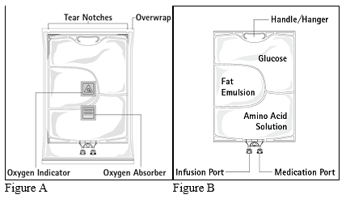

Figure A: The multichamber bag is packed in a protective overwrap. An oxygen absorber and an oxygen indicator are placed between the bag and the overwrap; the oxygen absorber sachet is made of inert material and contains iron hydroxide.

Figure B: The top chamber contains a glucose solution, the middle chamber contains a fat emulsion, and the bottom chamber contains an amino acid solution.

The top chamber and the middle chamber can be connected with the bottom chamber by opening the intermediate seams (peel seams).

The design of the bag permits mixing of the amino acids, glucose, lipids and electrolytes in a single chamber. Opening the peel seams results in sterile mixing to form an emulsion.

The different container sizes are presented in cartons containing five bags.
Pack sizes: 5 x 625 ml, 5 x 1250 ml and 5 x 1875 ml.

Not all pack sizes may be marketed.

  - Special precautions for disposal of a used medicine or waste materials derived from such medicine and other handling of the product
No special requirements for disposal.

Parenteral nutrition products should be visually inspected for damage, discolouration, and emulsion instability before use.

Do not use bags which are damaged. Overwrap, primary bag and the peel seams between the chambers should be intact. Only use if the amino acid and glucose solutions are clear and colourless up to straw- coloured and the lipid emulsion is homogenous with milky white appearance. Do not use if the solutions contain particulate matter. After mixing the three chambers do not use if the emulsion shows discolouration or signs of phase separation (oil drops, oil layer). Stop the infusion immediately in case of discolouration of the emulsion or signs of phase separation.

Before opening the overwrap, check the colour of the oxygen indicator (see Figure A). Do not use if the oxygen indicator turned pink. Use only if the oxygen indicator is yellow.

Preparation of the mixed emulsion:
Strict adherence to aseptic handling principles must be complied with.

To open: Tear overwrap starting from the tear notches (Fig. 1). Remove the bag from its protective overwrap. Discard overwrap, oxygen indicator and oxygen absorber.

Visually inspect the primary bag for leaks. Leaky bags must be discarded, since the sterility cannot be guaranteed.

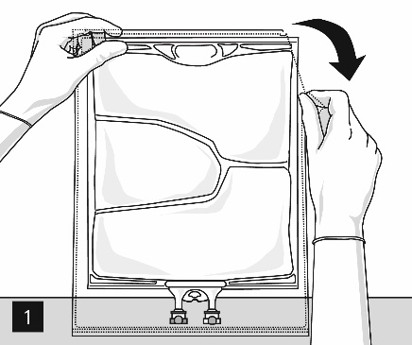

Mixing of the bag and additions of additives
To open and mix the chambers sequentially, roll the bag with both hands, starting first by opening the peel seam that separates the top chamber (glucose) and the bottom chamber (amino acids) (Fig. 2a). After mixing of the two clear aqueous solutions, compatible additives should be added via the medication port (Fig. 4).
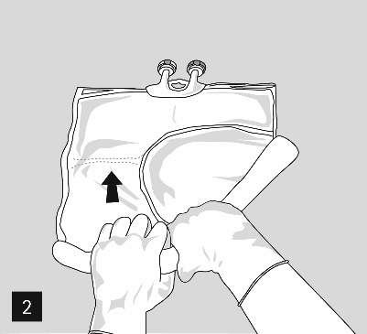
Addition of additives
After removing the aluminium seal (Fig. 3) one can add compatible additives via the medication port (Fig. 4) to the clear aqueous solutions. Mix the contents thoroughly (Fig.5) and visually inspect the mixture for precipitations (Fig. 6). Only clear solution must be used.
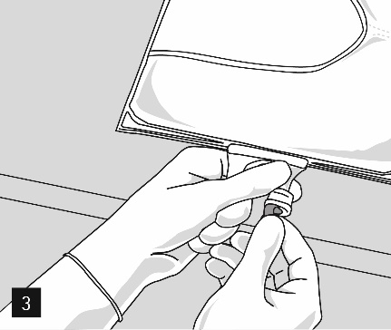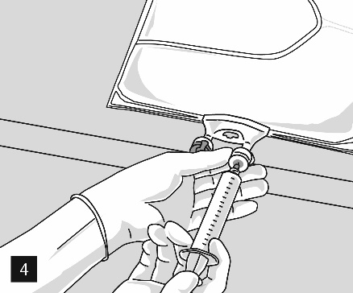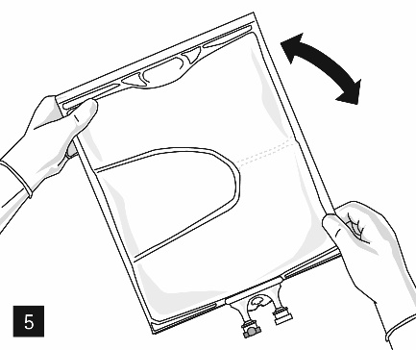
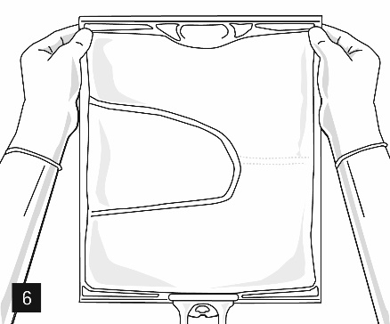
Then continue applying pressure so that the peel seam separating the middle chamber (lipids) and the bottom chamber opens (Fig. 7). The mixture is a milky white homogenous oil-in-water emulsion. One can add compatible additives after all chambers are mixed via the medication port (Fig. 4). Mix the contents thoroughly (Fig. 8) and visually inspect the mixture (Fig. 9).
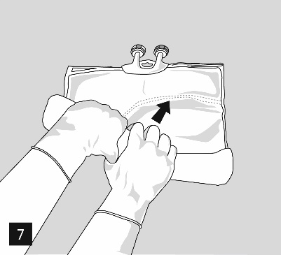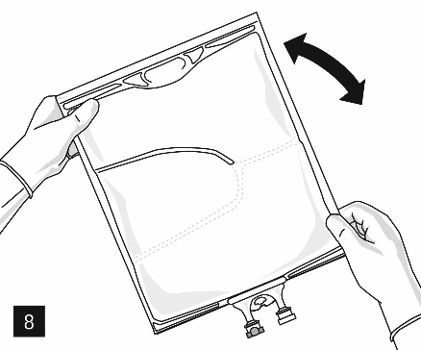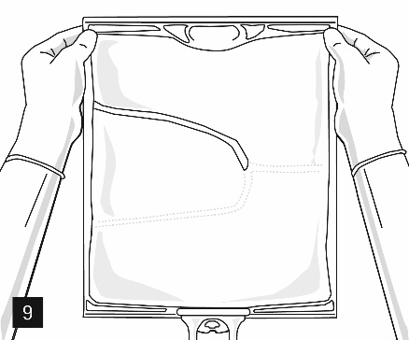

Nutriflex Omega Specialized can be mixed with the following additives up to the below specified upper concentration limits or maximum amount of additives after supplementation.
The resulting admixtures are stable for 7 days between + 2 °C to + 8 °C plus 2 days at 25 °C.

- Electrolytes: take account of the electrolytes already present in the bag; stability has been demonstrated up to a total quantity of 200 mmol/l of sodium + potassium (sum), 9,6 mmol/l of magnesium and 6,4 mmol/l of calcium in the ternary mixture.

- Phosphate: stability has been demonstrated up to a maximum concentration of 20 mmol/l for inorganic phosphate or up to a maximum concentration of 30 mmol/l for organic phosphate (not both at the same time).

- Alanyl-Glutamin up to 24 g/l.

- Trace elements and vitamins: stability has been demonstrated with commercially available multi-trace elements and multi-vitamins (e.g. Viant, Tracutil, Cernevit) up to the standard dosage recommended by the respective manufacturer of the micronutrient.

Detailed information about the above mentioned additives and the corresponding shelf life of such admixtures can be provided on demand by the manufacturer.

Preparation for infusion
The emulsion should always be brought to room temperature prior to infusion.

Remove the aluminium foil from the infusion port (Fig. 10) and attach the infusion set (Fig. 11). Use a non-vented infusion set or close the air vent when using a vented set. Hang the bag on an infusion stand (Fig. 12) and carry out infusion using the standard technique.

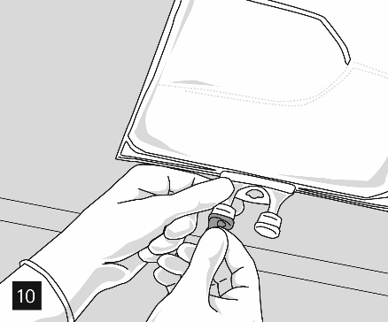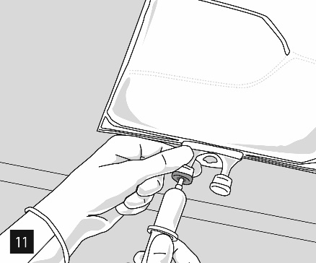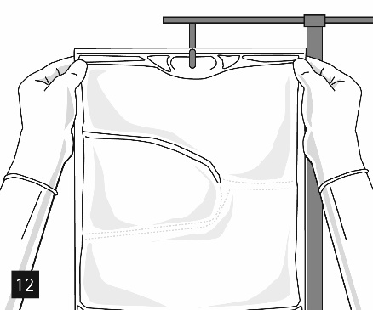
For single use only. Container and unused residues must be discarded after use.
Do not reconnect partially used containers.
If filters are used they must be lipid-permeable (pore size ≥ 1,2 µm).

- holder of the certificate of registration
B.Braun Medical (Pty) Ltd
2523 Aintree Road, Hoogland Ext. 41,
Northriding, 2196,
Gauteng, Republic of South Africa
Tel: +27 (010) 222 3000

- REGISTRATION NUMBER (S)
49/25/0065
- DATE OF FIRST AUTHORISATION
30 August 2022
- DATE OF REVISION OF TEXT
N/A

